AI-Driven Employee Feedback Analysis System:

“Fostering Workplace Harmony”

Group12

Sk.Bashee - AP23110010241
P.Sujith – AP23110010541
D.Prabath – AP23110010565
G.Bhargav Sai – AP23110010435
S.Ajay Kumar – AP23110010211

December 1, 2025

- Project Description 4
- Project Scenarios 4
  - Scenario 1: Real-Time Employee Feedback Analysis . . . . . . . . . . . . 4
  - Scenario 2: Bulk Feedback Processing and Trend Analysis . . . . . . . . 4
  - Scenario 3: Proactive Employee Retention and Engagement . . . . . . . . 4
- Technical Diagram 5
- Prerequisites 5
  - Software Requirements . . . . . . . . . . . . . . . . . . . . . . . . . . . . 5
    - Anaconda Navigator and Visual Studio Code . . . . . . . . . . . . 5
    - Python Packages . . . . . . . . . . . . . . . . . . . . . . . . . . . 6
  - Prior Knowledge . . . . . . . . . . . . . . . . . . . . . . . . . . . . . . . 6
    - ML Concepts . . . . . . . . . . . . . . . . . . . . . . . . . . . . . 6
    - NLP Concepts . . . . . . . . . . . . . . . . . . . . . . . . . . . . . 6
    - Web Development . . . . . . . . . . . . . . . . . . . . . . . . . . . 7
- Project Flow 7
- Project Activities 8
  - Data Collection & Preparation . . . . . . . . . . . . . . . . . . . . . . . . 8
  - Exploratory Data Analysis . . . . . . . . . . . . . . . . . . . . . . . . . . 8
  - Model Building . . . . . . . . . . . . . . . . . . . . . . . . . . . . . . . . 8
  - Performance Testing & Model Selection . . . . . . . . . . . . . . . . . . . 8
  - Advanced Features Implementation . . . . . . . . . . . . . . . . . . . . . 8
  - Model Deployment . . . . . . . . . . . . . . . . . . . . . . . . . . . . . . 9
- Project Structure 9
  - Project Structure Explanation . . . . . . . . . . . . . . . . . . . . . . . . 9
- Milestone 1: Data Collection & Preparation 10
  - Activity 1.1: Collect the Dataset 10
    - Dataset Source 10
  - Activity 1.2: Importing the Libraries 11
  - Activity 1.3: Read the Dataset 11
  - Activity 1.4: Exploratory Data Analysis (EDA) 12
    - Outlier Analysis 12
    - Histogram Analysis 13
    - Univariate Analysis 14
    - Bivariate Analysis 15
    - Correlation Analysis 16
    - Pair Plot Analysis 17
  - Activity 1.5: Data Preparation 19
  - Activity 1.6: Convert Ratings to Sentiment Labels 20
  - Activity 1.7: Check Class Balance 20
- Milestone 2: Model Training & Evaluation 20
  - Activity 2.1: TF-IDF Vectorization 20
  - Activity 2.2: Train Machine Learning Models 21
  - Activity 2.3: Model Evaluation 21
  - Activity 2.4: Save Model and Vectorizer 21
- Milestone 3: Advanced Features Implementation 22
  - Activity 3.1: Theme Extraction 22
  - Activity 3.2: Emotion Detection 22
  - Activity 3.3: Mixed Feedback Logic 22
  - Activity 3.4: AI Summary Generation 23
- Milestone 4: Web Application Development 23
  - Activity 4.1: Flask Backend API 23
  - Activity 4.2: Additional API Endpoints 24
- Frontend Implementation 25
  - Key Features of the Web Application 25
    - User Interface Components 25
    - Analysis Display Components 25
    - Advanced Features 25
- Application Screenshots and Workflow 26
  - Home Page Interface 26
  - Employee Feedback Input Form 27
  - Analysis Results Display 27
  - Export Functionality 28
- Model Performance Metrics 29
- Future Implementations 29
  - Advanced NLP Models 29
  - Real-time Integration 29
  - Advanced Analytics 29
  - Enhanced User Experience 30
- Conclusion 30
- Technical Specifications 30
  - Model Architecture 30
  - System Requirements 31
  - API Endpoints 31
- References and Resources 31

Project Description
The AI-Driven Employee Feedback Analysis System is an advanced Natural Language Processing (NLP) and Machine Learning project designed to analyze employee feedback and provide actionable insights for Human Resources (HR) departments. The system utilizes supervised learning algorithms, including Naive Bayes and Logistic Regression, combined with TF-IDF vectorization to classify employee feedback into sentiment cate- gories (Positive, Neutral, Negative). By examining text patterns, emotional indicators, and workplace themes, the model assists HR professionals in understanding employee satisfaction, identifying areas of concern, and making data-driven decisions to improve workplace culture and employee retention.
The system goes beyond simple sentiment classification by extracting key themes (such as salary, workload, management, culture), detecting emotions (joy, stress, anger, frustration, motivation), generating AI-powered summaries, and providing department- wise sentiment analysis. The final product is a full-stack web application built with Flask that seamlessly integrates the trained model into an intuitive, modern HR dashboard interface.

Project Scenarios

Scenario 1: Real-Time Employee Feedback Analysis
An HR manager receives employee feedback through an anonymous survey or feedback portal. The AI-Driven Employee Feedback Analysis System processes the text input in real-time, analyzing sentiment, extracting key themes, detecting emotional indicators, and generating actionable insights. Within seconds, the system provides a comprehensive analysis including sentiment classification, confidence scores, identified themes, emotion breakdown, and AI-generated recommendations, enabling HR professionals to quickly understand employee concerns and prioritize interventions.

Scenario 2: Bulk Feedback Processing and Trend Analysis
HR departments conduct quarterly employee satisfaction surveys, collecting hundreds or thousands of feedback responses. The system processes all feedback entries efficiently, identifying sentiment trends across different departments, job roles, and time periods. The department-wise sentiment analysis feature helps HR identify which departments require immediate attention, while theme extraction reveals common concerns such as workload pressure, compensation issues, or management problems. This enables HR to make strategic decisions about resource allocation, training programs, and policy changes.

Scenario 3: Proactive Employee Retention and Engagement
In organizations with high turnover rates, the system analyzes historical and real-time employee feedback to identify early warning signs of dissatisfaction. By detecting negative sentiment patterns, stress indicators, and frustration markers, HR can proactively reach out to at-risk employees, address concerns before they escalate, and implement targeted interventions. The AI summary feature provides quick insights that help HR managers prepare for one-on-one conversations and develop personalized retention strategies.

Technical Diagram

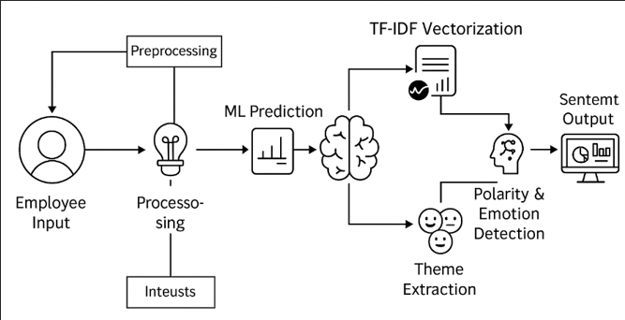

Figure 1: System Architecture and Workflow Diagram

Prerequisites
To complete this project, you must require the following software, concepts, and packages:

Software Requirements

Anaconda Navigator and Visual Studio Code
      - Refer to the link below to download Anaconda Navigator

      - Link: https://youtu.be/1ra4zH2G4o0

Python Packages

Open anaconda prompt as administrator and install the following packages:
pip install pandas pip install numpy
pip install scikit-learn pip install matplotlib pip install seaborn
pip install nltk pip install flask
pip install flask-cors pip install joblib
pip install wordcloud
pip install imbalanced-learn pip install emoji
pip install textblob

Prior Knowledge
You must have prior knowledge of the following topics to complete this project.

ML Concepts
      - Supervised Learning: https://www.javatpoint.com/supervised-machine-learning
      - Text Preprocessing: Understanding of NLP preprocessing techniques (tokeniza- tion, lemmatization, stopword removal)
      - TF-IDF Vectorization: https://www.geeksforgeeks.org/tf-idf-model-for-page-rankin
      - Naive Bayes Classifier: https://www.javatpoint.com/machine-learning-naive-bayes-cl
      - Logistic Regression: https://www.javatpoint.com/logistic-regression-in-machine-lea
      - Evaluation Metrics: https://www.analyticsvidhya.com/blog/2019/08/11-important-mod
      - SMOTE: For handling imbalanced datasets

NLP Concepts
      - Natural Language Processing Basics: Tokenization, stemming, lemmatization
      - Sentiment Analysis: Understanding of sentiment classification approaches
      - Text Feature Extraction: TF-IDF, n-grams, feature selection

Web Development
      - Flask Basics: https://www.youtube.com/watch?v=lj4LCvBnt0
      - RESTful API Design: Understanding of HTTP methods and JSON responses
      - HTML/CSS/JavaScript: Basic frontend development knowledge
      - Chart.js: For data visualization

Project Flow
The project follows these sequential steps:
- Data Collection: User provides employee feedback dataset (CSV format) contain- ing employee reviews, ratings, and metadata.
- Data Preprocessing: System preprocesses the input data using comprehensive text cleaning (lowercase conversion, emoji removal, URL removal, special character removal, tokenization, lemmatization, stopword removal).
- Dataset Preparation: System converts overall ratings to sentiment labels (1-2 → negative, 3 → neutral, 4-5 → positive), checks class balance, and prepares the final dataset.
- Feature Engineering: System applies TF-IDF vectorization with n-gram extrac- tion (unigrams and bigrams) to convert text into numerical features suitable for machine learning.
- Model Training: Integrated machine learning model (Naive Bayes or Logistic Regression) analyzes the vectorized features and learns patterns from labeled data.
- Model Evaluation: System evaluates model performance using accuracy, preci- sion, recall, F1-score, and confusion matrix metrics.
- Theme Extraction: System extracts top HR-related keywords and themes from the feedback corpus using TF-IDF and CountVectorizer.
- Real-Time Inference: When user enters new feedback through the web interface, the system preprocesses input, vectorizes it, and makes sentiment predictions with confidence scores.
- Advanced Analysis: System performs additional analysis including theme ex- traction, emotion detection, polarity scoring, and AI summary generation.
- Results Display: Prediction results (Positive/Neutral/Negative sentiment) are displayed with confidence metrics, themes, emotions, AI summary, and department- wise insights through an interactive HR dashboard.

Project Activities

Data Collection & Preparation
- Collect the employee feedback dataset
- Data preprocessing and cleaning
- Rating-to-sentiment conversion
- Class balance analysis

Exploratory Data Analysis
- Descriptive statistics
- Visual analysis (word clouds, distribution charts)
- Univariate and bivariate analysis
- Class distribution visualization

Model Building
- Training the model with multiple algorithms (Naive Bayes, Logistic Regression)
- TF-IDF vectorization with hyperparameter tuning
- Testing different classifiers
- Handling imbalanced datasets (SMOTE)

Performance Testing & Model Selection
- Testing model with multiple evaluation metrics (Accuracy, Precision, Recall, F1- Score)
- Comparing model accuracy across different algorithms
- Confusion matrix analysis
- Selecting the best performing model

Advanced Features Implementation
- Theme extraction from feedback
- Emotion detection
- AI summary generation
- Department-wise sentiment analysis
- Mixed feedback logic and override rules

Model Deployment
- Save the best model and vectorizer
- Integrate with Flask Web Framework
- Create RESTful API endpoints
- Build modern HR dashboard UI

Project Structure
The project folder structure is organized as follows:
Gen/

app.py # Flask backend application
preprocess_data.py # Data preprocessing script
prepare_dataset.py # Dataset preparation script
train_model.py # Model training script
extract_themes.py # Theme extraction script
run_pipeline.py # Pipeline orchestration script

employee_reviews.csv # Raw dataset
processed_data.csv # Preprocessed data (generated)
final_dataset.csv # Final dataset with sentiment labels

sentiment_model.pkl # Trained model file (generated)
vectorizer.pkl # TF-IDF vectorizer (generated) extracted_keywords.txt # Extracted keywords (generated) wordcloud.png # Word cloud visualization
requirements.txt # Python dependencies templates/
index.html # Web UI template

Project Structure Explanation
- app.py: Flask application backend that handles API endpoints, model inference, and advanced analysis features (emotion detection, theme extraction, AI sum- maries).
- preprocess_data.py: Script for loading and cleaning the employee feedback dataset. Handles text preprocessing including lowercase conversion, emoji removal, URL removal, tokenization, lemmatization, and stopword removal.
- prepare_dataset.py: Script that converts overall ratings to sentiment labels, checks class balance, and prepares the final dataset for training.

- train_model.py: Model training script that implements TF-IDF vectorization, trains Naive Bayes or Logistic Regression classifiers, evaluates performance, and saves the trained model.
- extract_themes.py: Script for extracting top HR-related keywords and themes from employee feedback using TF-IDF and CountVectorizer, and generating word cloud visualizations.
- templates/index.html: Modern HR dashboard UI with sentiment badges, con- fidence meters, theme tags, emotion visualization, interactive charts, dark/light mode, and export functionality.
- sentiment_model.pkl: Trained machine learning model file (saved using joblib).
- vectorizer.pkl: TF-IDF vectorizer file (saved using joblib).

Milestone 1: Data Collection & Preparation
Data collection is fundamental to machine learning, providing the raw material for train- ing algorithms and making predictions. This process involves gathering relevant informa- tion from various sources such as databases, surveys, and feedback portals. The quality, quantity, and diversity of collected data significantly impact the performance and accu- racy of ML models.

Activity 1.1: Collect the Dataset
There are many popular open sources for collecting data. For example: kaggle.com, UCI repository, etc. In this project, we have used CSV data. This data can be downloaded from kaggle.com or other data repositories.
Dataset Source Examples:
- https://www.kaggle.com/datasets/petersunga/google-amazon-facebook-employee-revie
- https://www.kaggle.com/datasets/ambarish/indeed-job-reviews-dataset

Dataset Source
The dataset used in this project contains employee feedback and reviews from various companies. The dataset includes the following features:
      - summary: Employee review summary text
      - pros&cons: Pros and cons of working at the company
      - overall-ratings: Overall rating (1-5 stars)
      - job-title: Job title or role of the employee
      - location: Location of the employee/company
      - company: Company name
The dataset file is named employee_reviews.csv and contains multiple employee records with their feedback, ratings, and metadata.

Activity 1.2: Importing the Libraries
Import the necessary libraries as shown below:
import numpy as np import pandas as pd
import matplotlib . pyplot as plt import seaborn as sns
import nltk
from nltk . corpus import stopwords
from nltk . tokenize import word_tokenize from nltk . stem import Word NetLemmatizer import re
import emoji
from sklearn . feature_extraction . text import TfidfVectorizer from sklearn . naive_bayes import MultinomialNB
from sklearn . linear_model import LogisticRegression
from sklearn . metrics import accuracy_score , precision_score , recall_score , f1 _score
import joblib
from flask import Flask , request , jsonify , render_template from textblob import TextBlob
1

2

3

4

5

6

7

8

9

10

11

12

13

14

15

16

17

18

These libraries serve the following purposes:
- NumPy: For numerical computations
- Pandas: For data manipulation and analysis
- Matplotlib: For creating visualizations
- Seaborn: For statistical data visualization
- NLTK: For natural language processing (tokenization, stopwords, lemmatization)
- scikit-learn: For machine learning algorithms and evaluation metrics
- Flask: For web application framework
- TextBlob: For sentiment polarity analysis
- joblib: For model persistence

Activity 1.3: Read the Dataset
Our dataset is in CSV format. We read the dataset using pandas:
df = pd. read_csv (’ employee_reviews. csv ’, encoding =’ latin -1 ’, low_memory = False )
df. head ()
1

2

3

Sample Output:

summary | pros&cons | overall-ratings | job-title
Great company culture | Good benefits, work-life... | 5 | Software Engineer
Stressful environment | High pressure, long hours | 2 | Manager
Average workplace | Okay benefits, decent pay | 3 | Analyst

Table 1: Sample Dataset Preview

The head() function displays the first 5 rows of the dataset, giving us a quick overview of the data structure and values.

Activity 1.4: Exploratory Data Analysis (EDA)
Before preprocessing, we perform comprehensive Exploratory Data Analysis to under- stand the data distribution, identify outliers, and discover patterns. This analysis in- cludes visual analysis, univariate analysis, bivariate analysis, correlation analysis, and pair plot analysis.

Outlier Analysis
Outlier detection helps identify data points that deviate significantly from the rest of the dataset. We use box plots to visualize outliers in numerical features such as feedback length, word count, and ratings.

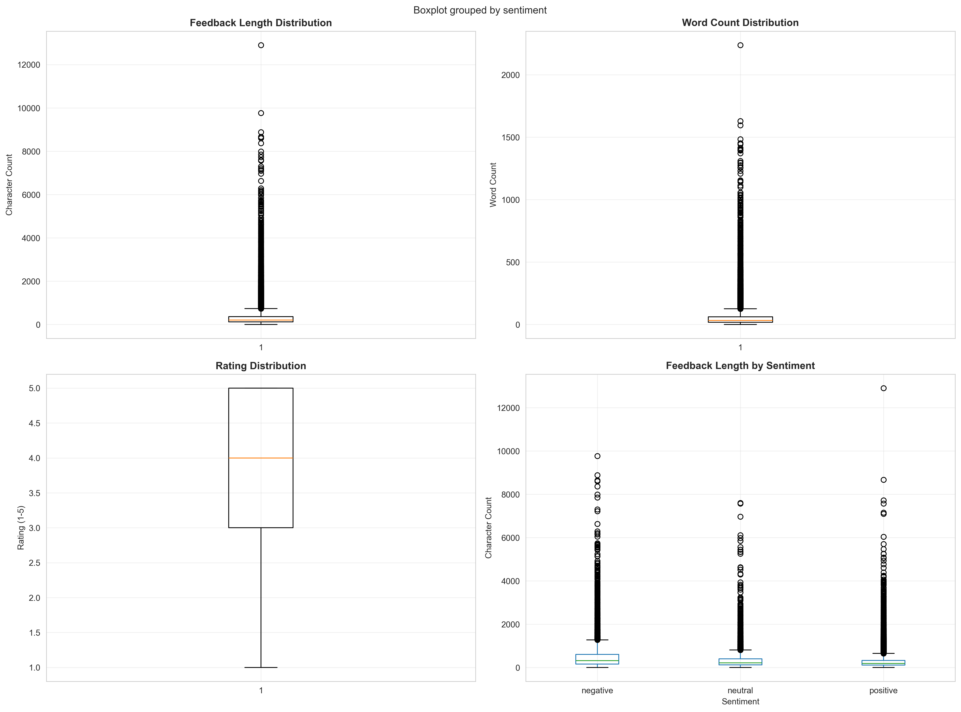

Figure 2: Outlier Analysis - Box Plots

The box plots reveal:
      - Distribution of feedback length (character count)
      - Distribution of word count per feedback
      - Rating distribution (if available)
      - Feedback length variation across different sentiment classes

Histogram Analysis
Histograms provide insights into the frequency distribution of numerical variables, helping us understand the data’s underlying distribution patterns.

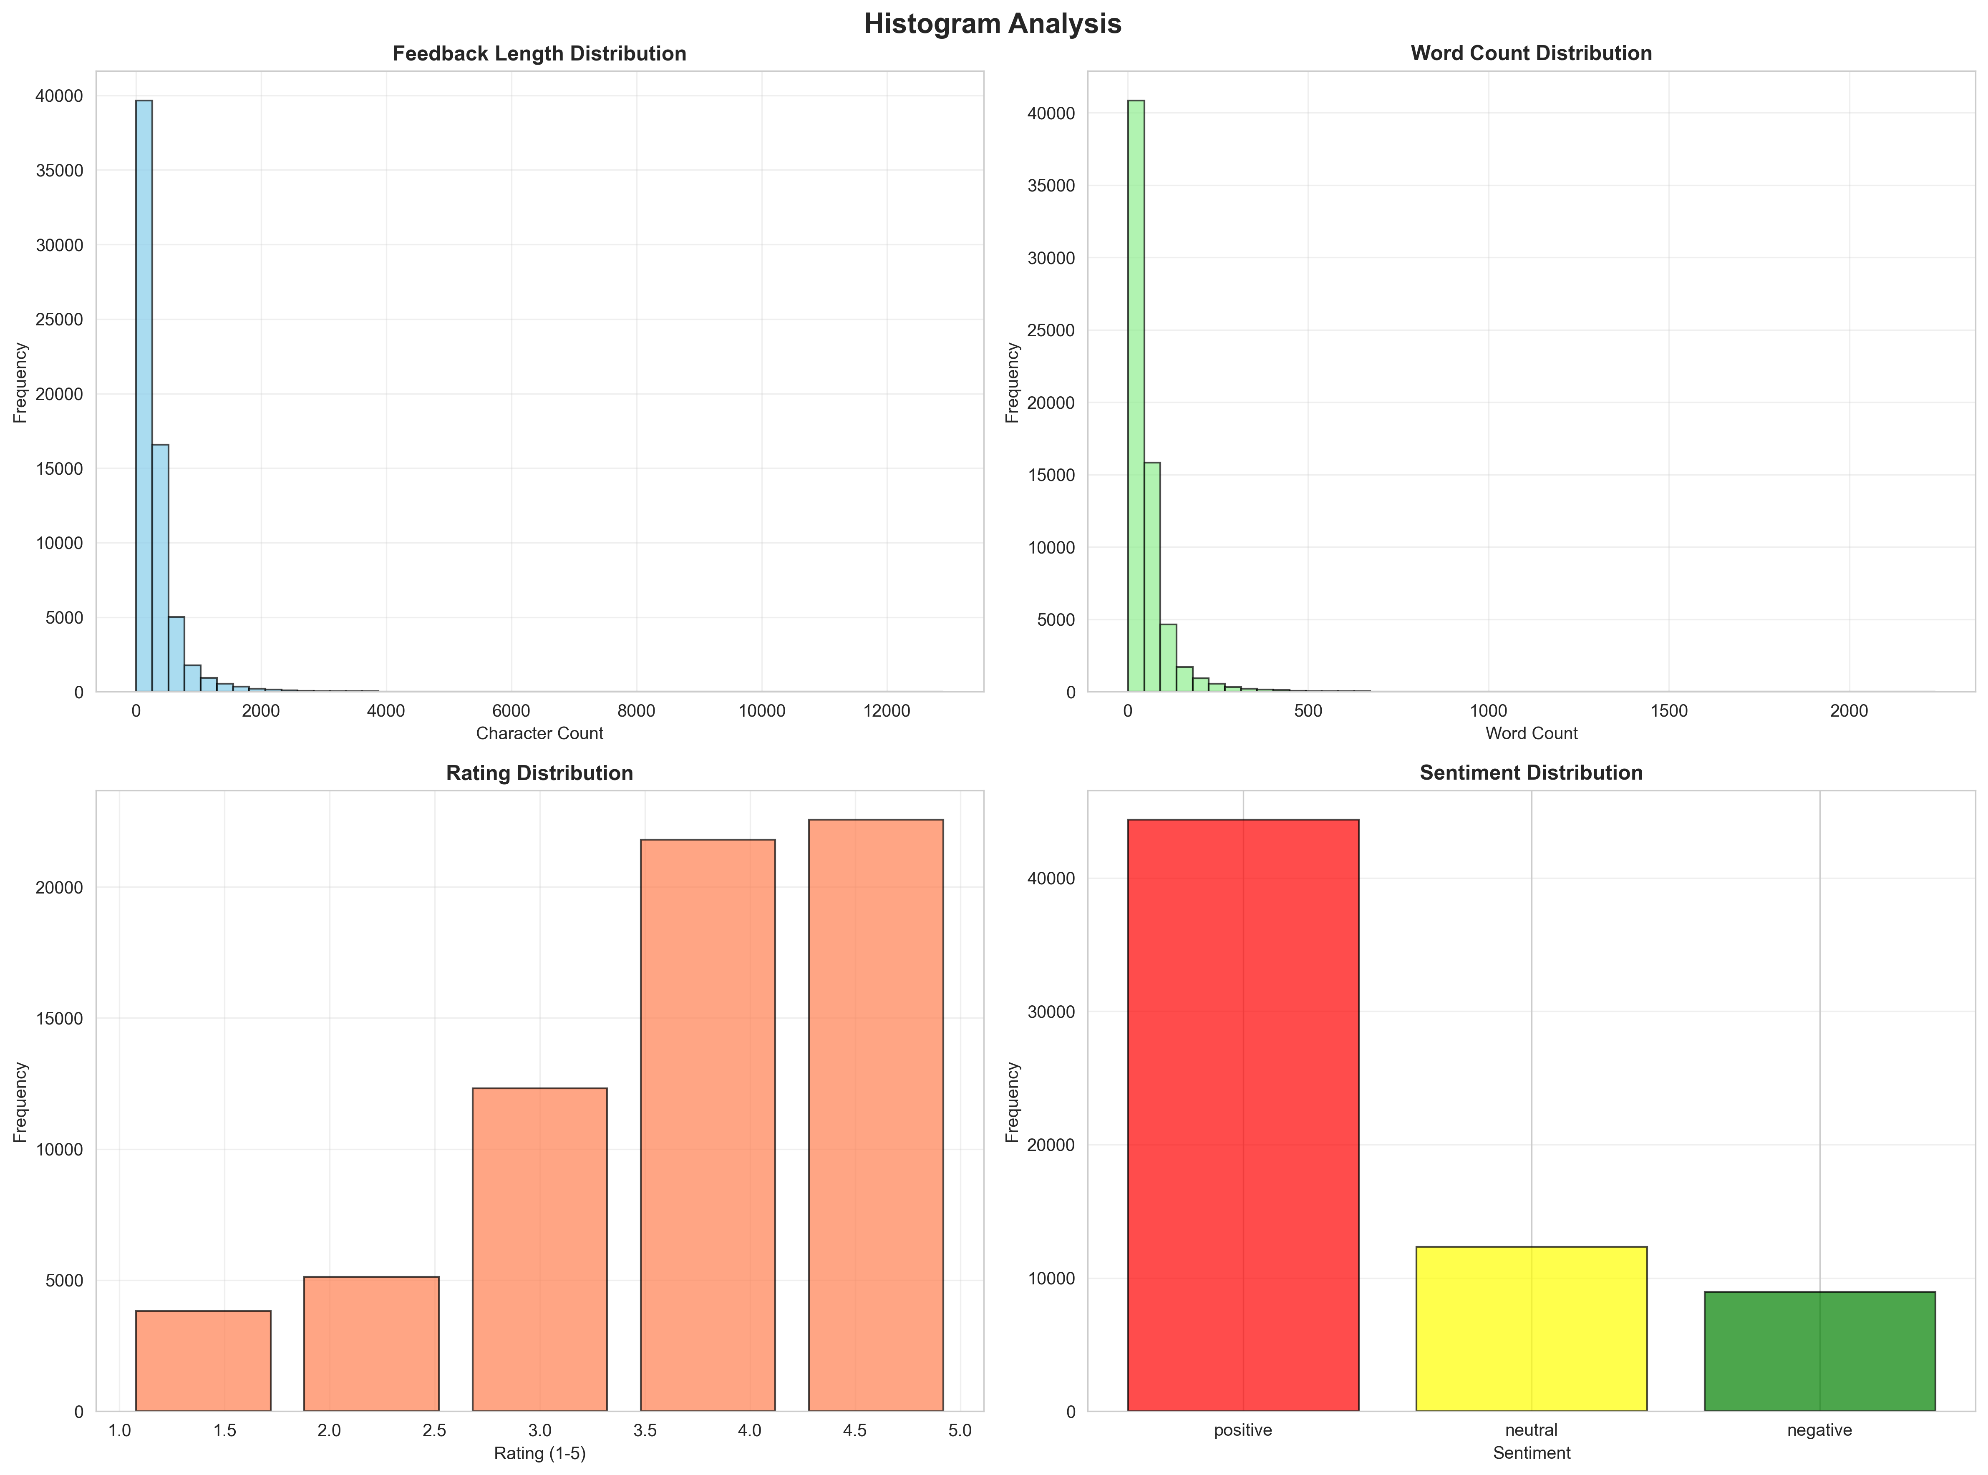

Figure 3: Visual Analysis - Histogram

The histograms show:
      - Frequency distribution of feedback length
      - Frequency distribution of word count
      - Rating frequency distribution
      - Sentiment class distribution

Univariate Analysis
Univariate analysis examines individual variables in isolation, combining histograms with Kernel Density Estimation (KDE) to understand the probability distribution of each feature.

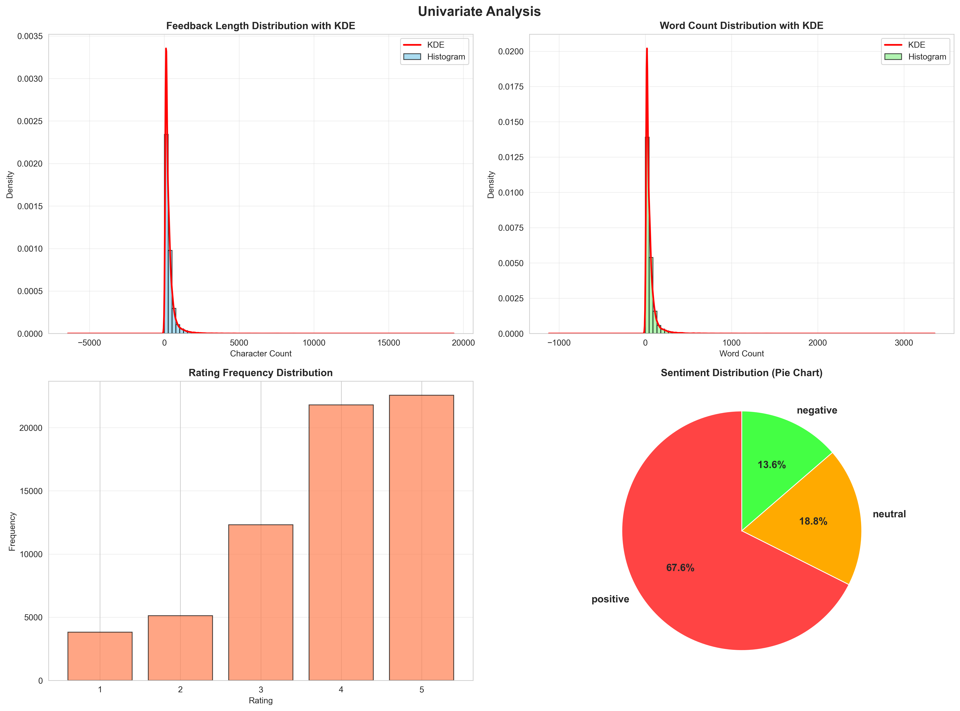

Figure 4: Univariate Analysis with KDE

Key observations:
      - Feedback length distribution with density curve
      - Word count distribution with density curve
      - Rating frequency patterns
      - Sentiment class proportions (pie chart)

Bivariate Analysis
Bivariate analysis explores relationships between two variables, helping identify correla- tions and patterns between different features.

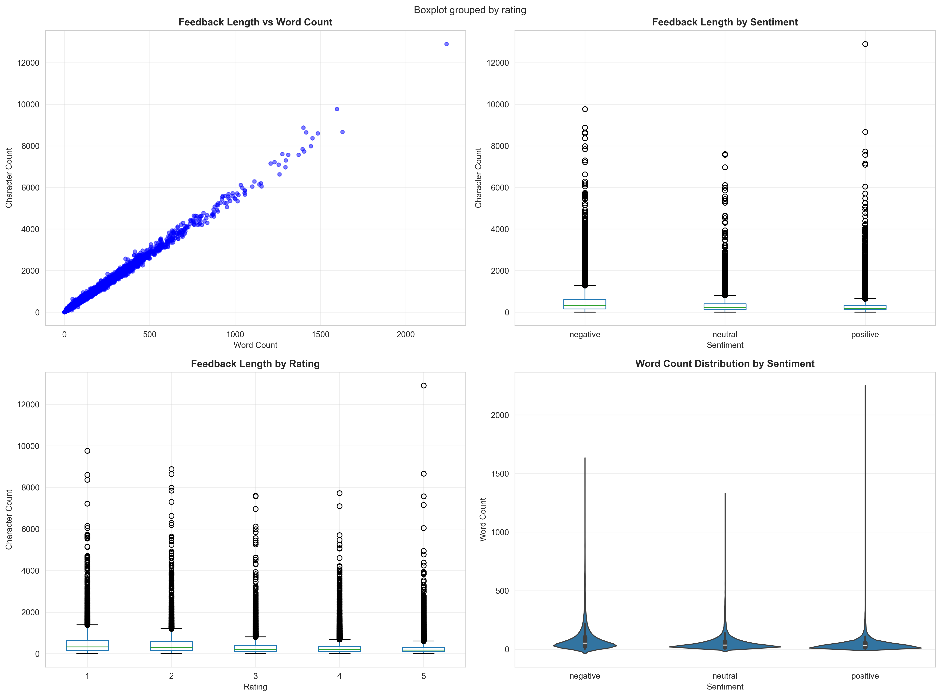

Figure 5: Bivariate Analysis

The bivariate plots reveal:
      - Relationship between word count and feedback length (scatter plot)
      - Feedback length variation across sentiment classes (box plot)
      - Feedback length variation across ratings (box plot)
      - Word count distribution by sentiment (violin plot)

Correlation Analysis
Correlation analysis measures the strength and direction of linear relationships between numerical variables using correlation coefficients.

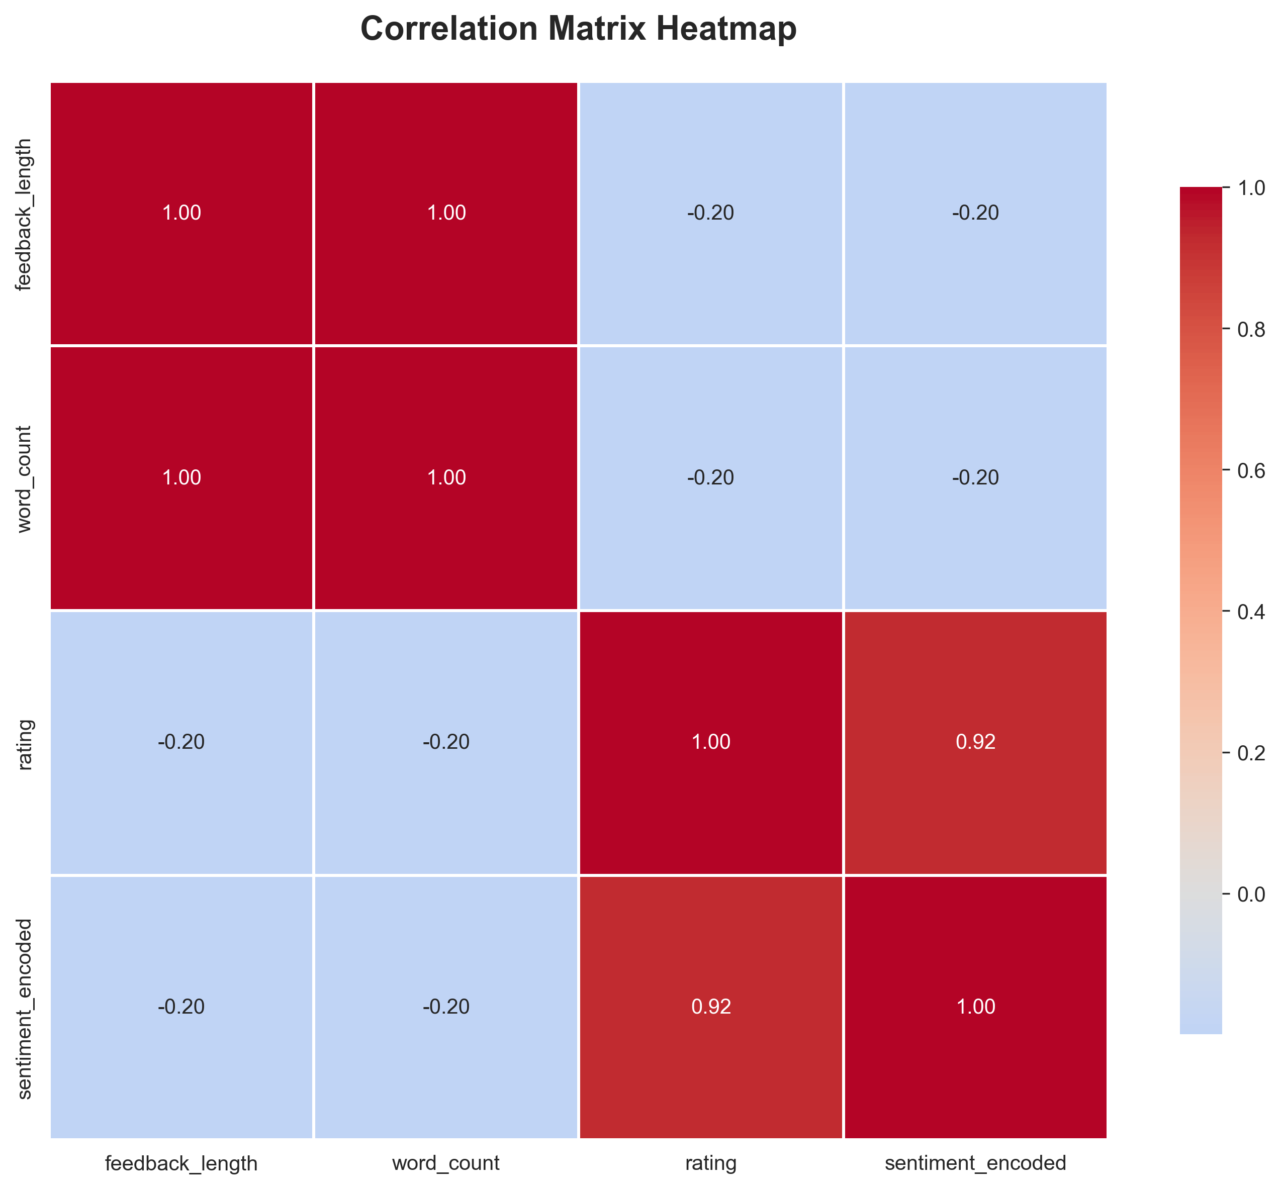

Figure 6: Correlation Matrix Heatmap

The correlation heatmap shows:
      - Correlation coefficients between all numerical features
      - Strong positive correlations (red) and negative correlations (blue)
      - Features with weak or no correlation (white/yellow)

Pair Plot Analysis
Pair plots provide a comprehensive view of relationships between all pairs of numerical variables, with diagonal plots showing univariate distributions.

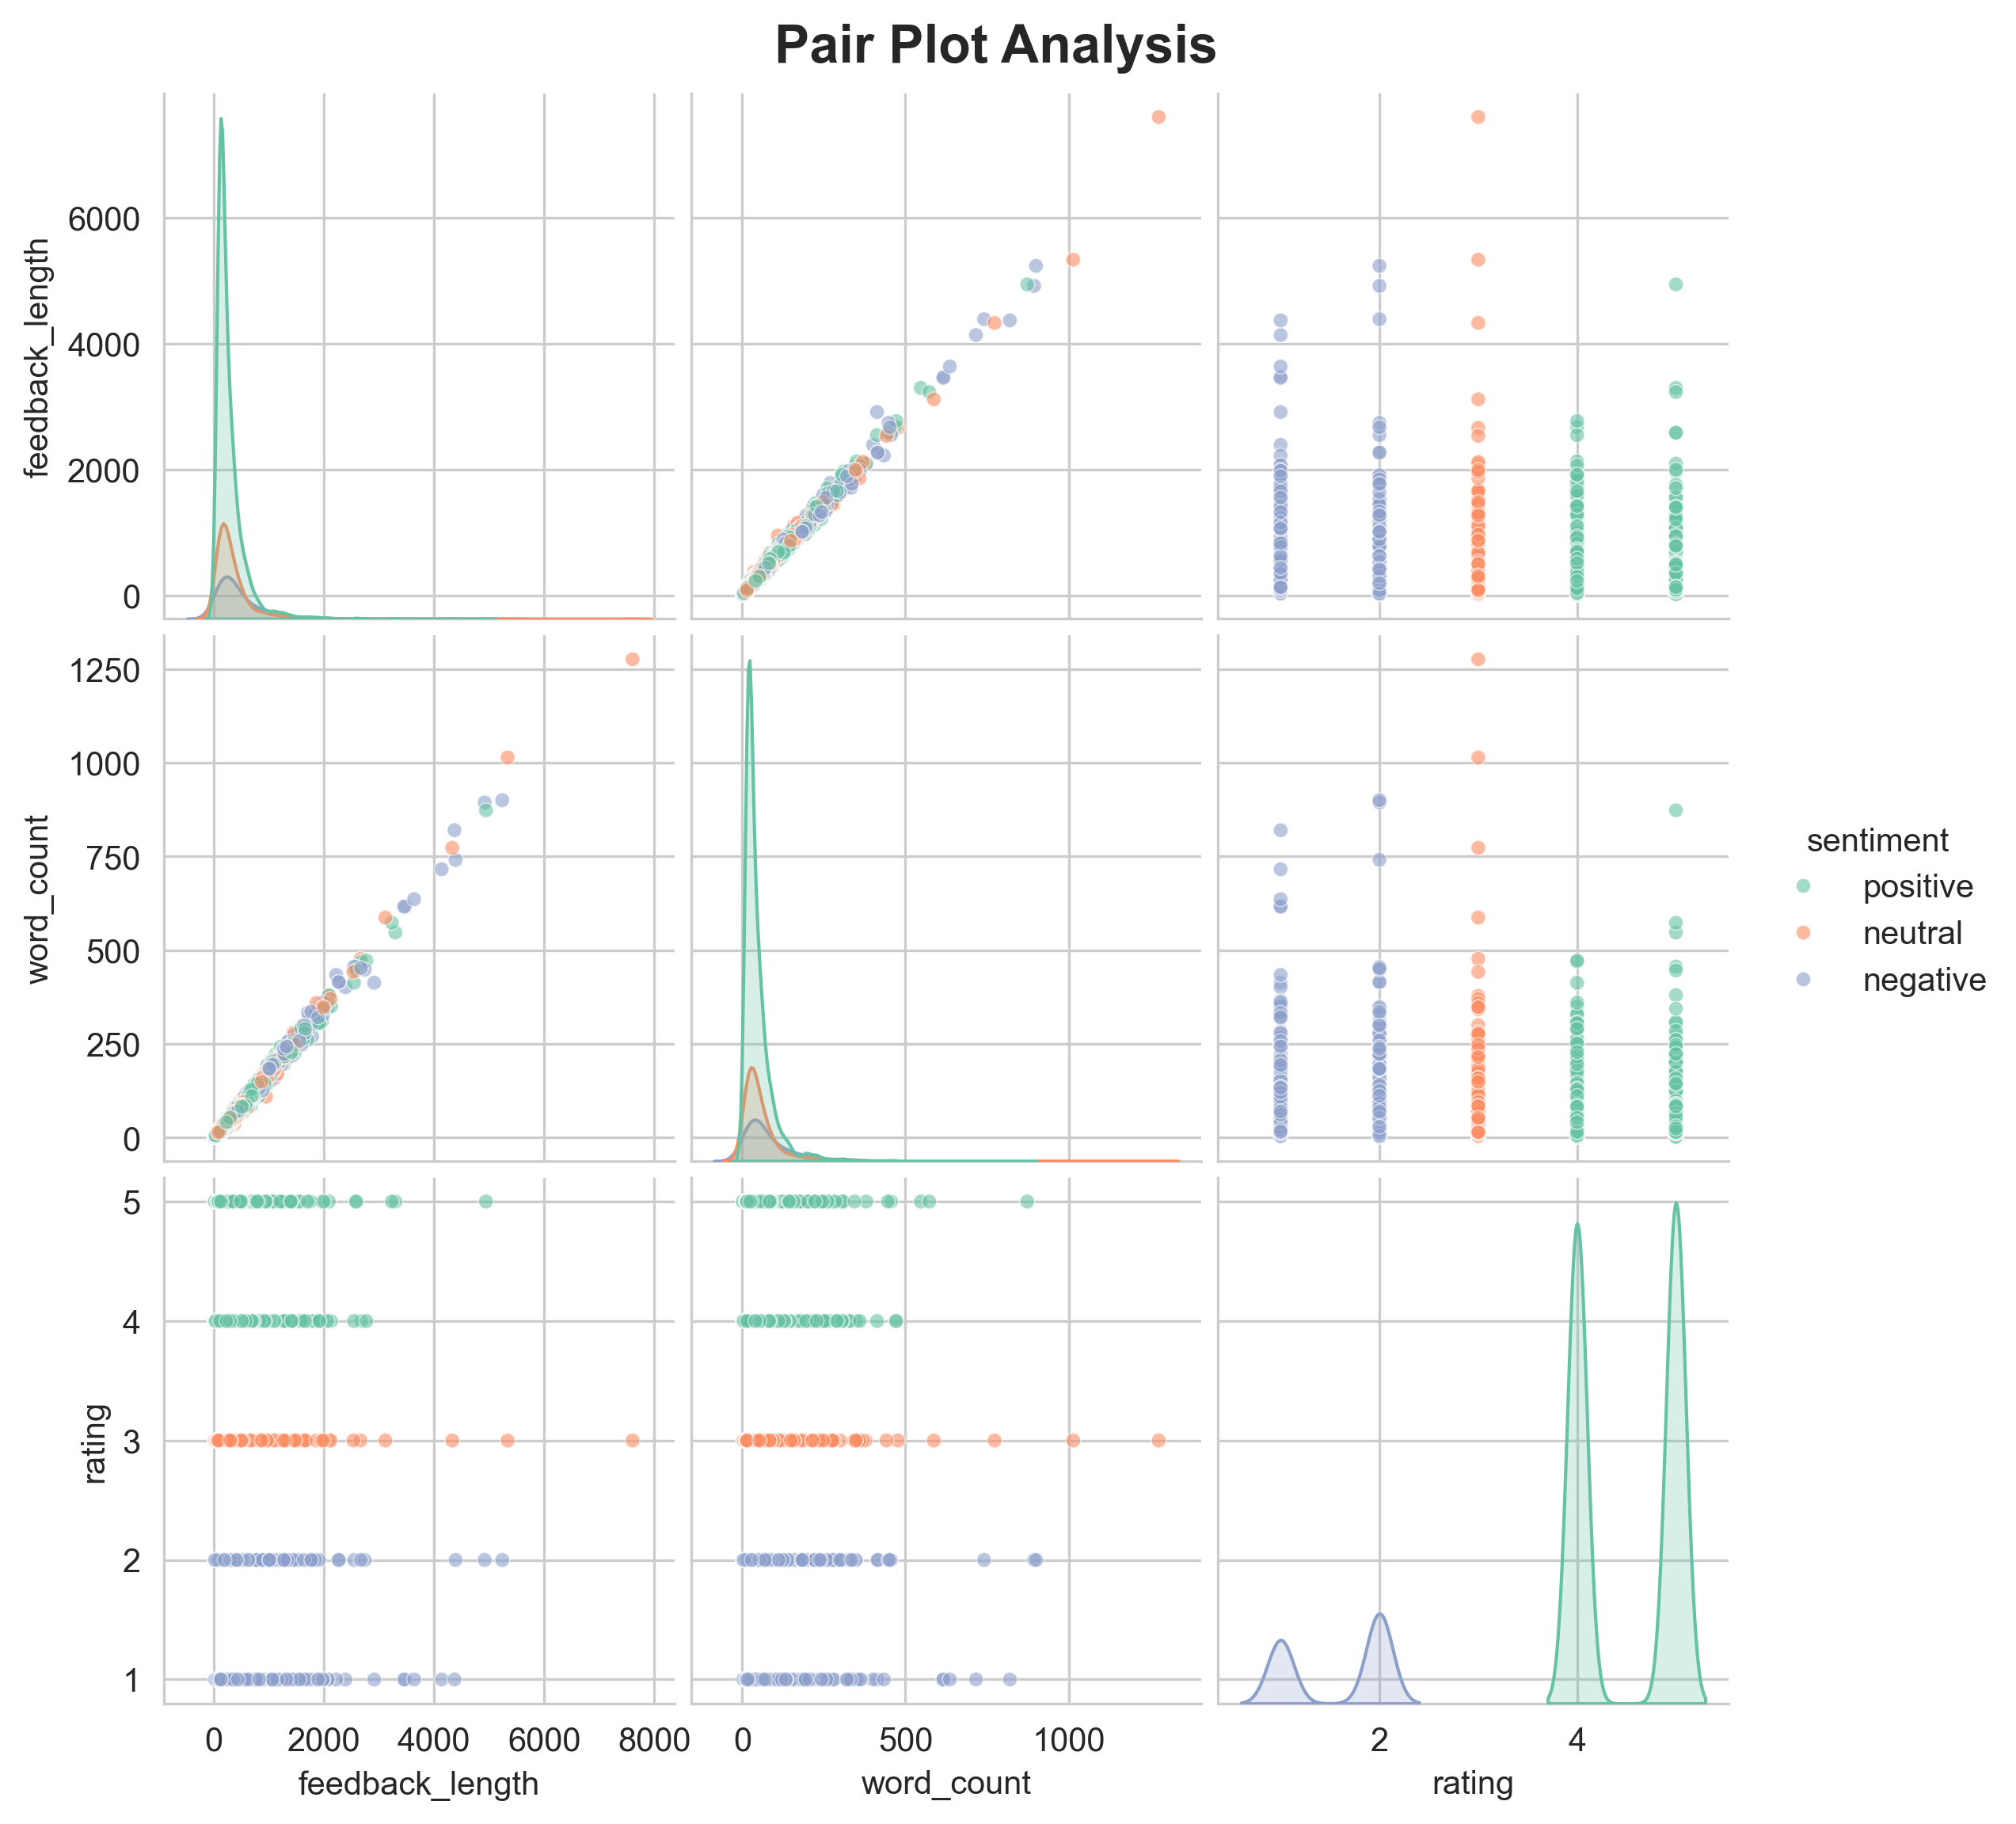

Figure 7: Pair Plot Analysis
The pair plot displays:
      - Scatter plots for all variable pairs
      - KDE plots on the diagonal showing univariate distributions
      - Color coding by sentiment class (if available)
      - Comprehensive overview of all variable relationships

Code for Generating EDA Visualizations:
# Run the EDA visualization script python generate_eda_visualizations . py
1

2

This script generates all six types of visualizations automatically and saves them in the eda_visualizations/ folder.

Activity 1.5: Data Preparation
Before we can use our data to teach our machine-learning model, we need to clean it up. This includes:
- Handling missing values: Remove or fill missing feedback entries
- Combining columns: Merge ’summary’ and ’pros&cons’ into a single ’feedback’ column
- Text cleaning:
  - Convert to lowercase
  - Remove emojis
  - Remove URLs and email addresses
  - Remove special characters and punctuation
  - Remove numbers
  - Tokenization
  - Stopword removal
  - Lemmatization
Key Preprocessing Steps:
def clean_text( text):
# Convert to lowercase text = str( text). lower ()
tokens = [ lemmatizer. lemmatize ( token ) for token in tokens
if token not in stop_words and len ( token ) > 2]

return ’ ’. join ( tokens)
1

2

3

4
5 | # Remove emojis
6 | text = emoji. replace_emoji( text , replace =’’)
7
8 | # Remove URLs
9 | text = re. sub ( r’ http \ S+|www \ S+| https\ S+’, ’’, | text)
10
11 | # Remove email addresses
12 | text = re. sub ( r’\ S+@\ S+’, ’’, text)
13
14 | # Remove numbers
15 | text = re. sub ( r’\ d+’, ’’, text)
16
17 | # Remove special characters
18 | text = re. sub ( r’[^\ w\ s]’, ’ ’, text)
19
20 | # Tokenize and remove stopwords
21 | tokens = word_tokenize ( text)
22 | stop_words = set( stopwords. words(’ english ’))
23

24

25

26

Activity 1.6: Convert Ratings to Sentiment Labels
Convert overall ratings to sentiment categories:
- 1-2 stars → negative sentiment
- 3 stars → neutral sentiment
- 4-5 stars → positive sentiment

1
def convert_rating_to_sentiment ( rating ): if rating <= 2:
return ’ negative ’ elif rating == 3:
return ’ neutral ’ else : # 4 or 5
return ’ positive ’

df[’ sentiment ’] = df[’ overall - ratings ’]. apply ( convert_rating_to_sentiment )

2

3

4

5

6

7

8

9

10

Activity 1.7: Check Class Balance
Analyze the distribution of sentiment classes to identify imbalanced datasets:
print( df[’ sentiment ’]. value_counts ()) print( df[’ sentiment ’]. value_counts( normalize = True ) * 100)
1

2

If the dataset is imbalanced (ratio > 2.0), consider applying SMOTE during training.

Milestone 2: Model Training & Evaluation

Activity 2.1: TF-IDF Vectorization
Convert text data into numerical features using TF-IDF (Term Frequency-Inverse Docu- ment Frequency):
vectorizer = TfidfVectorizer( max_features =5000 ,
ngram_range =(1 , 2), # Unigrams and bigrams min_df=2 , # Minimum document frequency
max_df =0.95 # Maximum document frequency
)

X_train_tfidf = vectorizer. fit_transform ( X_train ) X_test_tfidf = vectorizer. transform ( X_test)
1

2

3

4

5

6

7

8

9

Activity 2.2: Train Machine Learning Models
Train multiple classifiers and compare their performance:
Naive Bayes:
from sklearn . naive_bayes import MultinomialNB model = MultinomialNB ( alpha =1.0) model. fit( X_train_tfidf , y_train )
1

2

3

Logistic Regression:
from sklearn . linear_model import LogisticRegression
model = LogisticRegression ( max_iter =1000 , random_state =42 ,
multi_class=’ multinomial ’) model. fit( X_train_tfidf , y_train )
1

2

3

4

Activity 2.3: Model Evaluation
Evaluate model performance using multiple metrics:
y_pred = model. predict( X_test_tfidf)

accuracy = accuracy_score ( y_test , y_pred )
precision = precision_score ( y_test , y_pred , average =’ weighted ’) recall = recall_score ( y_test , y_pred , average =’ weighted ’)
f1 = f1 _score ( y_test , y_pred , average =’ weighted ’)

print( f" Accuracy : { accuracy :.4 f}") print( f" Precision : { precision :.4 f}") print( f" Recall: { recall :.4 f}")
print( f"F1 - Score : { f1 :.4 f}")
1

2

3

4

5

6

7

8

9

10

11

Expected Results:
- Accuracy: 72-75%
- Precision: 66-70%
- Recall: 72-75%
- F1-Score: 65-70%

Activity 2.4: Save Model and Vectorizer
Save the trained model and vectorizer for deployment:
joblib . dump ( model , ’ sentiment_model. pkl’) joblib . dump ( vectorizer , ’ vectorizer. pkl’)
1

2

Milestone 3: Advanced Features Implementation

Activity 3.1: Theme Extraction
Extract top HR-related keywords and themes from feedback:
def extract_themes_from_text ( text , keywords_list): text_lower = text. lower ()
found_themes = []

hr_keywords = [’ salary ’, ’ workload ’, ’ culture ’, ’ management ’, ’ stress ’, ’ growth ’, ’ team ’, ’ support ’, ’ bonus ’, ’ environment ’]

for keyword in hr_keywords: if keyword in text_lower:
found_themes. append ( keyword )

return found_themes [:5]
1

2

3

4

5

6

7

8

9

10

11

12

13

Activity 3.2: Emotion Detection
Detect emotions in feedback text:
def detect_emotions( text): emotion_keywords = {
’ joy ’: [’ happy ’, ’ great ’, ’ amazing ’, ’ wonderful ’, ’ excellent ’],
’ stress ’: [’ stress ’, ’ stressful ’, ’ pressure ’, ’ overwhelming ’],
’ anger ’: [’ angry ’, ’ furious ’, ’ mad ’, ’ rage ’, ’ hate ’],
1

2

3

4

5
6  7 |  | ’ frustration ’: [’ frustrated ’, ’ disappointed ’, ’ upset ’,  ’ unhappy ’],  ’ motivation ’: [’ motivated ’, ’ inspired ’, ’ encouraged ’,
8 | } | ’ energized ’]
9
10 | # | Calculate emotion scores and percentages
11 | # | Return emotion distribution

Activity 3.3: Mixed Feedback Logic
Implement advanced sentiment override logic for mixed feedback:
# Check for negative indicators
negative_indicators = [’ too high ’, ’ pressure ’, ’ stressful ’,
’ bad ’, ’ terrible ’]

# Strong negative phrases
strong_negative_phrases = [’ toxic environment ’, ’ caustic work ’,
’no work life balance ’]
1

2

3

4

5

6

7

8
# Override logic: If strong negative phrases detected , # adjust sentiment
if has_strong_negative :
if prob_dict. get(’ negative ’, 0) > prob_dict. get(’ neutral ’, 0): sentiment = ’ negative ’
else :
sentiment = ’ neutral ’

# Critical override : If polarity is strongly negative ( < -0.2), # always negative
if polarity < -0.2: sentiment = ’ negative ’

9

10

11

12

13

14

15

16

17

18

19

20

Activity 3.4: AI Summary Generation
Generate contextual AI summaries for HR insights:
def generate_ai_summary ( feedback , sentiment , themes , emotions): summary_parts = []

# Sentiment - based insights if sentiment == ’ negative ’:
summary_parts. append (" Employees express concerns that
require attention .")

# Theme - based insights if ’ workload ’ in themes:
summary_parts. append (" Workload concerns suggest potential burnout risks.")

# Emotion - based insights
if emotions. get(’ stress ’, 0) > 30: summary_parts. append (" High stress levels detected -
consider
wellness programs.")

# Recommendations recommendations = []
if sentiment == ’ negative ’:
recommendations. append (" HR should explore workload
redistribution .")

return " ". join ( summary_parts + recommendations)
1

2

3

4

5

6

7

8

9

10

11

12

13

14

15

16

17

18

19

20

21

22

23

24

25

Milestone 4: Web Application Development

Activity 4.1: Flask Backend API
Create RESTful API endpoints for real-time inference:

1 from flask import Flask , request , jsonify , render_template
2 from flask_cors import CORS
3 import joblib
4
5 app = Flask ( __name__)
6 CORS ( app )
7
8 # Load model and vectorizer
9 model = joblib . load (’ sentiment_model. pkl’)
10 vectorizer = joblib . load (’ vectorizer. pkl’)
11
12 @app . route (’/ analyze_feedback ’, methods =[’ POST ’])
13 def analyze_feedback ():
14 data = request. get_json ()
15 feedback_text = data [’ feedback ’]
16
17 # Preprocess
18 cleaned_text = clean_text( feedback_text)
19
20 # Vectorize
21 text_tfidf = vectorizer. transform ([ cleaned_text ])
22
23 # Predict
24 sentiment = model. predict( text_tfidf)[0]
25 probabilities = model. predict_proba ( text_tfidf)[0]
26
27 # Advanced analysis
28 themes = extract_themes_from_text ( cleaned_text , hr_keywords)
29 emotions = detect_emotions( cleaned_text)
30 ai_summary = generate_ai_summary ( feedback_text , sentiment ,
31 themes , emotions)
32
33 return jsonify ({
34 ’ sentiment ’: sentiment ,
35 ’ confidence ’: {
36 ’ positive ’: probabilities [0],
37 ’ neutral ’: probabilities [1],
38 ’ negative ’: probabilities [2]
39 },
40 ’ themes ’: themes ,
41 ’ emotions ’: emotions ,
42 ’ ai_summary ’: ai_summary
43 })

Activity 4.2: Additional API Endpoints
Implement additional endpoints for enhanced functionality:
- /random_sample: Get random feedback sample from dataset

- /department_sentiment: Get department-wise sentiment analysis
- /model_metrics: Get model evaluation metrics
- /export_report: Export analysis results as CSV

Frontend Implementation
The web interface is designed with a modern, professional HR dashboard approach, op- timizing for clarity and usability.

Key Features of the Web Application

User Interface Components
      - Professional HR dashboard header for a trustworthy presentation
      - Comprehensive feedback analysis form for entering employee feedback text
      - Mobile-responsive design using CSS Grid and Flexbox for universal access
      - Dark/Light mode toggle for user preference
      - Interactive charts using Chart.js for data visualization

Analysis Display Components
      - Sentiment Badge: Color-coded sentiment indicator (Green for Positive, Yellow for Neutral, Red for Negative)
      - Confidence Progress Bars: Visual representation of model confidence scores for each sentiment class
      - Theme Tags: Display extracted HR-related themes as clickable tags
      - Emotion Visualization: Pie chart or bar chart showing emotion distribution
      - AI Summary Box: Generated insights and recommendations for HR
      - Department Sentiment Chart: Interactive bar/line chart showing sentiment across departments
      - Model Accuracy Log Panel: Display model evaluation metrics (accuracy, pre- cision, recall, F1-score)

Advanced Features
      - Random Sample Analyzer: Button to load and analyze random feedback from the dataset
      - Export Functionality: Download analysis results as CSV file
      - Real-time Inference: Instant analysis as user types or submits feedback
      - Mixed Feedback Logic: Advanced sentiment classification for complex feedback

Application Screenshots and Workflow
The workflow moves sequentially from data input to comprehensive HR insights.

Home Page Interface
Features:
- Clean, modern interface with gradient header
- Prominent feedback input textarea
- Quick action buttons (Analyze, Random Sample, Export)
- Dark/Light mode toggle in navigation bar

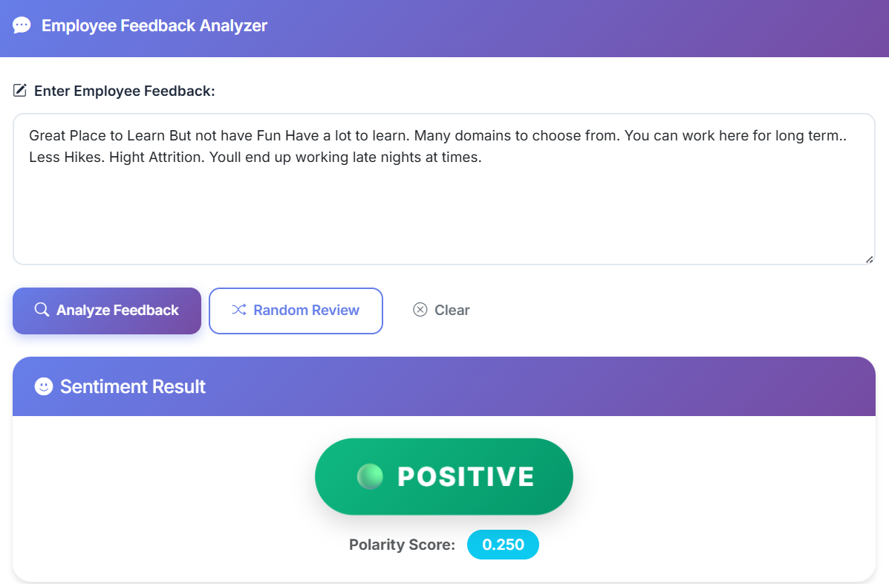

Figure 8: Page Interface

Employee Feedback Input Form
Form Components:
- Feedback Text Area: Large text input for employee feedback (supports multi-line text)
- Analyze Button: Triggers real-time sentiment analysis
- Random Sample Button: Loads random feedback from dataset for testing
- Clear Button: Resets the form

Analysis Results Display
Results Include:
- Sentiment Classification: Large badge showing "Positive", "Neutral", or "Neg- ative" with color coding
- Confidence Scores: Progress bars showing percentage confidence for each senti- ment class
- Polarity Score: TextBlob polarity score (-1 to +1) displayed with interpretation
- Extracted Themes: Tag-based display of identified themes
- Emotion Distribution: Visual chart (pie or bar) showing detected emotions
- AI Summary: Generated insights and recommendations
- Department Sentiment Chart: Interactive Chart.js visualization showing sen- timent breakdown by department
- Model Metrics Panel: Display of model evaluation metrics

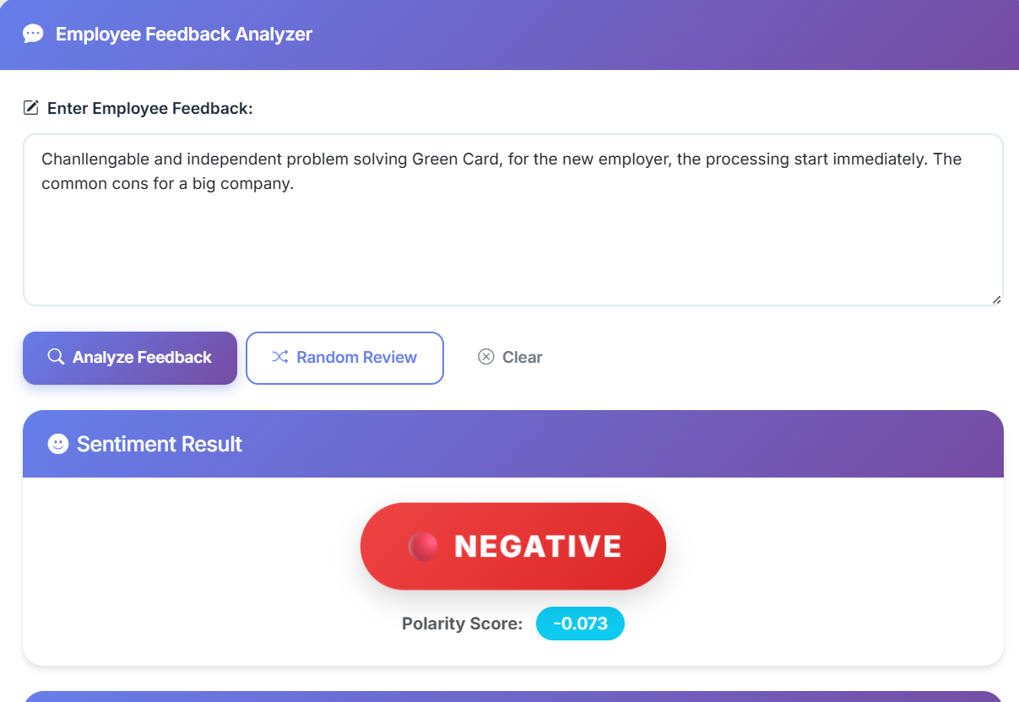

Figure 9: Analysis Results Display

Export Functionality
Users can export analysis results as CSV files containing:
- Timestamp
- Original feedback text
- Cleaned text
- Sentiment classification
- Confidence scores
- Polarity score
- Extracted themes
- Emotion distribution
- AI summary

Model Performance Metrics

Metric | Value
Accuracy | 72.10%
Precision | 66.04%
Recall | 72.10%
F1-Score | 64.85%
Table 2: Model Performance Metrics

Future Implementations
Future plans for the AI-Driven Employee Feedback Analysis System focus on deployment, integration, and model enhancement:

Advanced NLP Models
- Transformer-based Models: Integrate DistilBERT or BERT for improved sen- timent classification accuracy
- Fine-tuning: Fine-tune pre-trained transformer models on domain-specific em- ployee feedback data
- Ensemble Methods: Combine multiple models (Naive Bayes, Logistic Regression, Transformers) using voting or stacking

Real-time Integration
- HRIS Integration: Develop API endpoints to integrate directly into Human Re- sources Information Systems (HRIS)
- Slack/Teams Bot: Create chatbot integration for real-time feedback analysis in workplace communication platforms
- Email Integration: Automatically analyze feedback from email surveys and gen- erate reports

Advanced Analytics
- Temporal Analysis: Track sentiment trends over time to identify patterns and seasonal variations
- Predictive Analytics: Predict employee turnover risk based on sentiment pat- terns and historical data
- Comparative Analysis: Compare sentiment across departments, job roles, loca- tions, and time periods

Enhanced User Experience
- Mobile Application: Develop native mobile apps (iOS/Android) for HR man- agers to analyze feedback on-the-go
- Dashboard Customization: Allow users to customize dashboard views and cre- ate personalized reports
- Multi-language Support: Extend sentiment analysis to support multiple lan- guages using multilingual models

Conclusion
The AI-Driven Employee Feedback Analysis System successfully developed an accurate and highly interpretable AI-powered sentiment analysis system for HR insights. By uti- lizing Naive Bayes and Logistic Regression algorithms with TF-IDF vectorization, the model achieved reliable classification based on employee feedback text. The final product is a robust, full-stack web application (built with Flask and scikit-learn) that seamlessly integrates the trained model into an intuitive, modern HR dashboard interface.
The system goes beyond simple sentiment classification by providing:
- Advanced Analysis: Theme extraction, emotion detection, and AI-powered sum- maries
- Department Insights: Department-wise sentiment analysis for targeted interven- tions
- Mixed Feedback Handling: Sophisticated logic to accurately classify complex feedback
- User-Friendly Interface: Modern, responsive UI with dark/light mode and in- teractive visualizations
- Export Capabilities: CSV export functionality for reporting and record-keeping
This solution offers a reliable, scalable, and instant tool for preliminary employee sentiment assessment, proving the project’s success from data science development to practical HR deployment. The system enables HR professionals to make data-driven de- cisions, identify areas of concern proactively, and improve workplace culture and employee satisfaction.

Technical Specifications

Model Architecture
- Algorithm: Multinomial Naive Bayes / Logistic Regression
- Vectorization: TF-IDF with n-grams (1, 2)
- Features: 5000 max features
- Classes: 3 (Positive, Neutral, Negative)

System Requirements
- Python Version: 3.8+
- RAM: Minimum 4GB (8GB recommended)
- Storage: 500MB for dataset and model files
- Browser: Modern browsers (Chrome, Firefox, Edge, Safari)

API Endpoints
- GET /: Render main UI page
- POST /analyze_feedback: Analyze employee feedback
- GET /random_sample: Get random feedback sample
- GET /department_sentiment: Get department-wise analysis
- GET /model_metrics: Get model evaluation metrics
- POST /export_report: Export analysis as CSV
- GET /health: Health check endpoint

References and Resources
- scikit-learn Documentation: https://scikit-learn.org/stable/
- NLTK Documentation: https://www.nltk.org/
- Flask Documentation: https://flask.palletsprojects.com/
- TextBlob Documentation: https://textblob.readthedocs.io/
- Chart.js Documentation: https://www.chartjs.org/
- TF-IDF Vectorization: https://scikit-learn.org/stable/modules/generated/ sklearn.feature_extraction.text.TfidfVectorizer.html
- Naive Bayes Classifier: https://scikit-learn.org/stable/modules/naive_bayes. html
- Logistic Regression: https://scikit-learn.org/stable/modules/generated/sklearn. linear_model.LogisticRegression.html

